Steps to install Kafka:

1. Prerequisite: Before installing Kafka, ZooKeeper must be installed and running on your cluster.
2. Click the add service tab on Ambari:

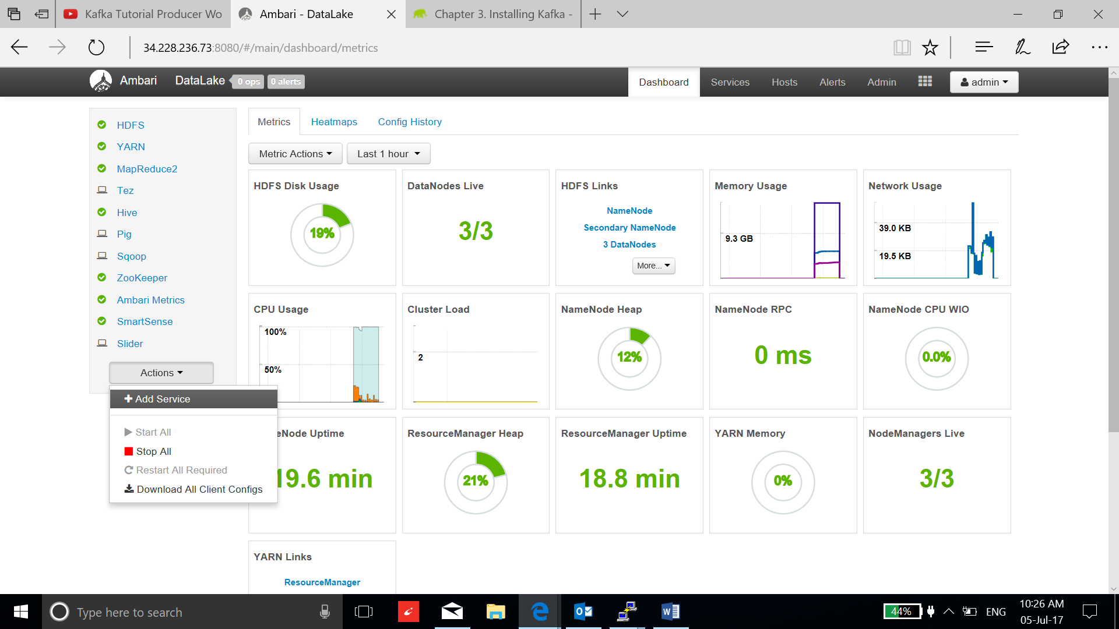

1. Check Kafka service and click next:

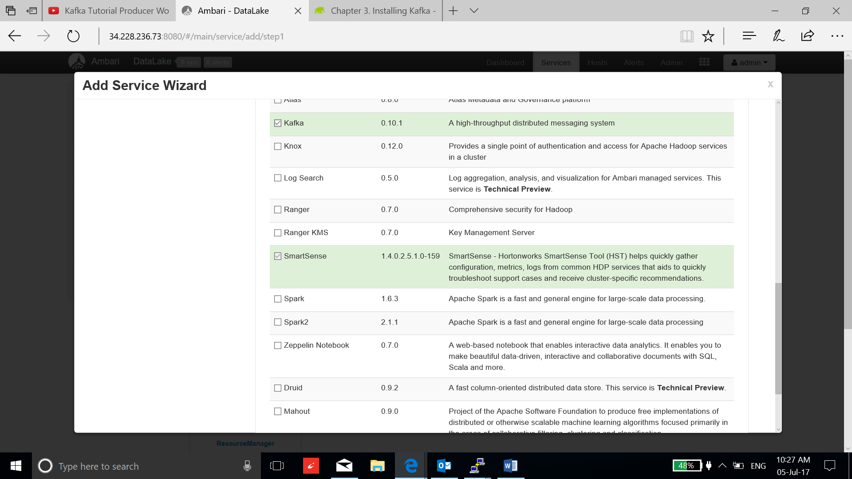

1. Assign Kafka broker to the master nodes:

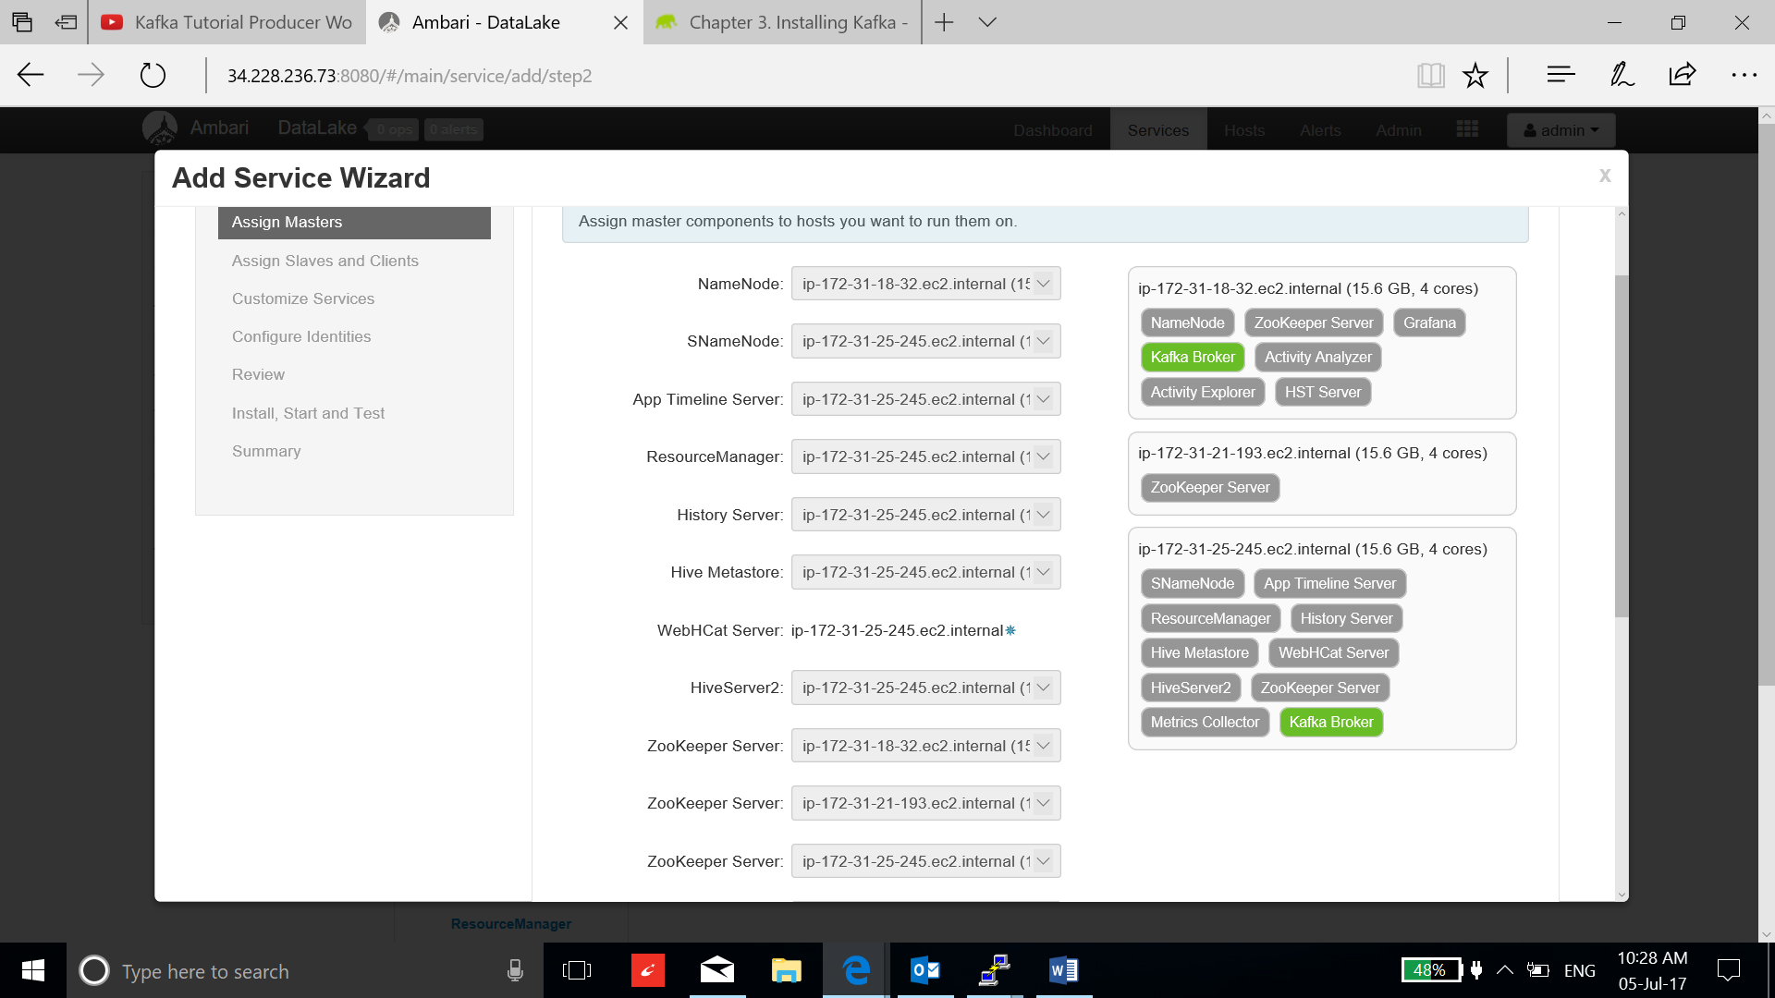

1. For your initial configuration use the default values set by Ambari. If Ambari prompts you with the message "Some configurations need your attention before you can proceed,", click Ok and next.

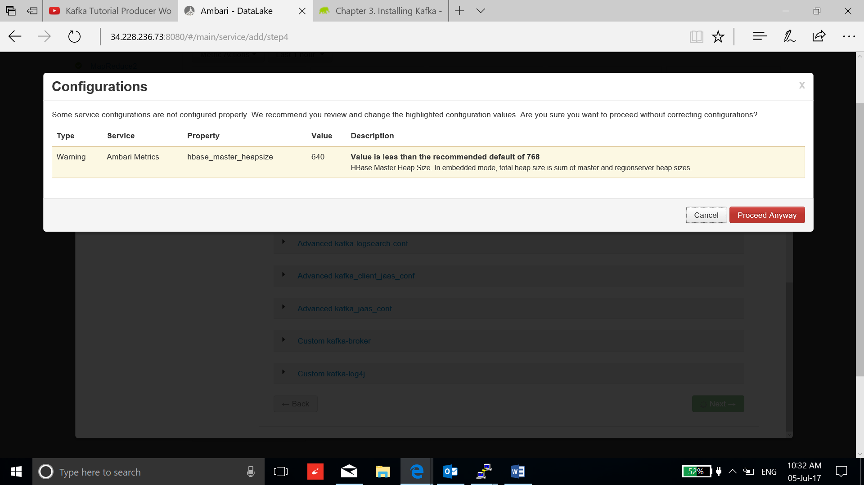

1. Click deploy and wait for installation:

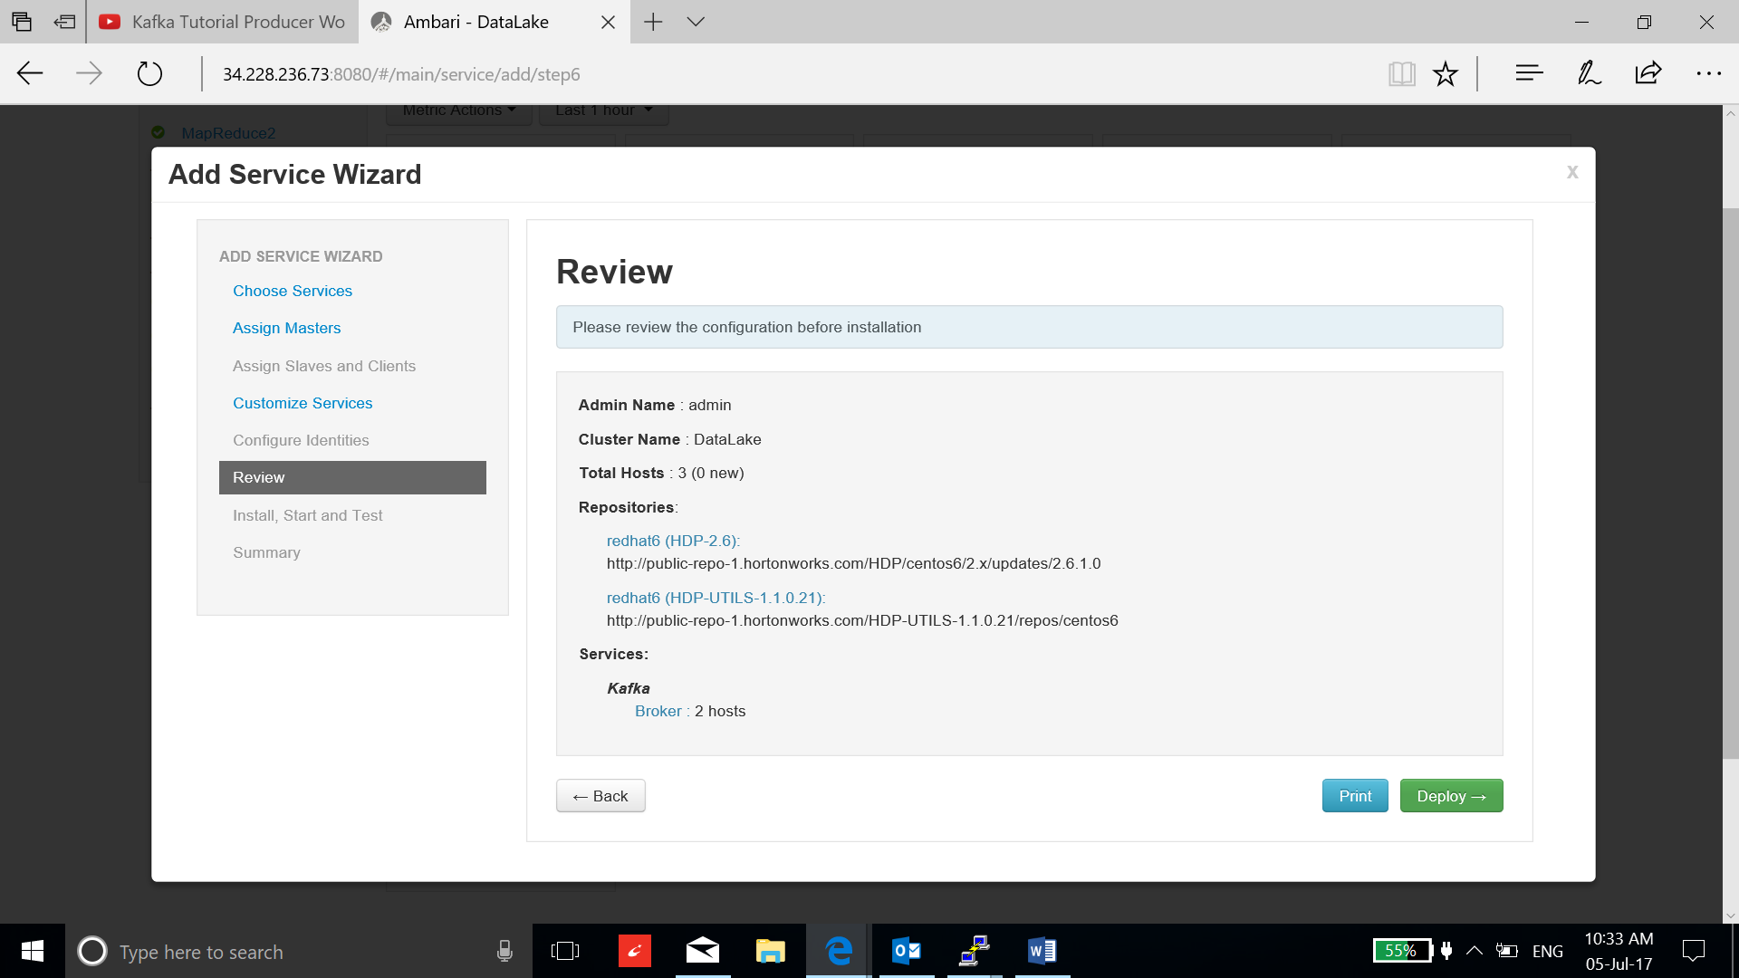

1. Click next and complete the installation:

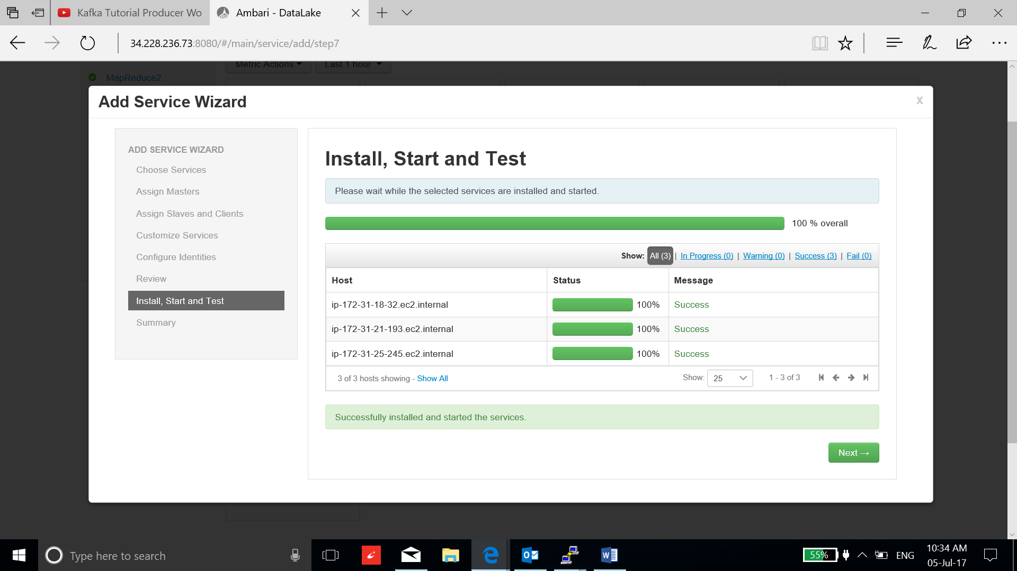

1. Create a topic:

**/usr/hdp/2.6.1.0-129/kafka/bin/kafka-topics.sh --zookeeper ip-172-31-25-245.ec2.internal:2181 --create --topic demo --partitions 2 --replication-factor 2**

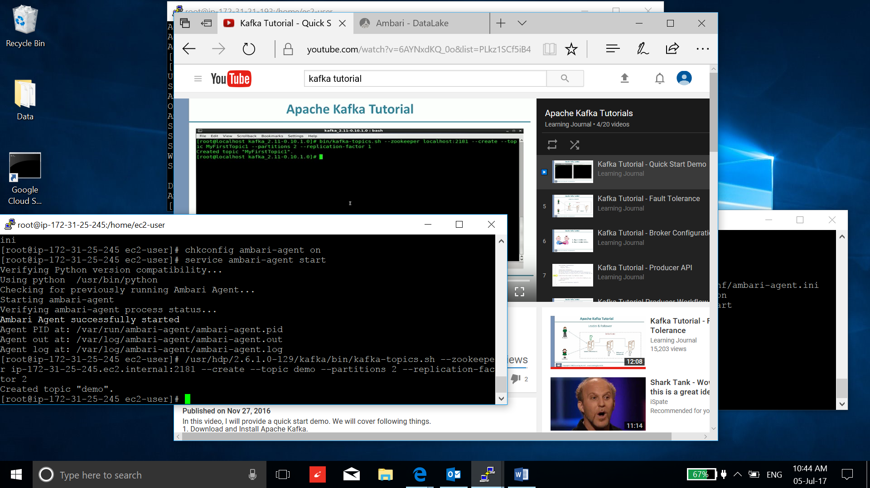

1. Run the console producer on one kafka broker’s instance and console consumer on the other one to test the Kafka installation:

**/usr/hdp/2.6.1.0-129/kafka/bin/kafka-console-producer.sh --broker-list ip-172-31-25-245.ec2.internal:6667 --topic demo**

**/usr/hdp/2.6.1.0-129/kafka/bin/kafka-console-consumer.sh --bootstrap-server ip-172-31-18-32.ec2.internal:6667 --topic demo**

Now the message link has been established, to test this link write the message on producer console and you can see the message transferring to the consumer console:

